**Practical 11:**

**Objective**: Solving Nonlinear Regression with Microsoft Excel

**Part A: (Exponential Regression)**

Fit an exponential model to the following dataset.

|  |  |  |  |  |  |  |
| --- | --- | --- | --- | --- | --- | --- |
| X | 0.4 | 0.8 | 1.2 | 1.6 | 2 | 2.3 |
| Y | 800 | 975 | 1500 | 1950 | 2900 | 3600 |

1. Write an equation for the exponential model.

y = A*e^(B*x )

1. What is the equation to fit the above dataset into an exponential model?

ln(y) = ln(A) + B*x

1. Find the above equation by using the following methods:
2. Excel Built-in Function

Using +logest(),

y = 546.59094*e^(0.81865*x)

1. Regression Data Analysis Tool

y = 546.59056*e^(0.81865*x)

1. Excel Built-in Graph

y = 546.59094*e^(0.81865*x)

**Part B: (Power Regression)**

Fit the following dataset into a power model.

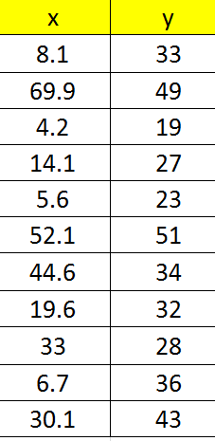

1. Write an equation for the power model.

y=A*x^B

1. What is the equation to fit the above dataset into a power model?

ln(y) = ln(A)+B*ln(x)

1. Use Excel built-in graph to find the power regression.

y = 16.65754*x^0.23438

4.Use Regression Data Analysis Tool to find the power regression with

* 1. transformation

y = 16.65749*x^0.23438

* 1. transformation

y = 16.65751*x^0.23438

5. Use Excel built-in function to find the power regression with

* 1. transformation

y = 16.65749*x^0.23438

* 1. transformation

y = 16.65751*x^0.23438

**Part C: (Saturated Growth Model)**

It is known that the following dataset can be modeled by $y={\left(\frac{a+\sqrt{x}}{b\sqrt{x}}\right)}^{2}$.

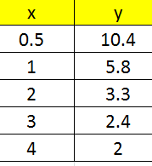

1. What is the equation to fit the above dataset into a linearize model?

y^(1/2) = (a/b) * (1/x^(1/2)) + 1/b

1. Use Excel built-in graph to find the above regression.

y^(1/2) = (1.99213) * (1/x^(1/2)) + 0.40979

1. Based on your analysis, predict $y$ at $x=1.6$

3.93906

**Part D: (Programming Practice)**

Write a program to fit dataset for nonlinear model. Your program should use a transformation to linearize the equation and then employ linear regression to determine the parameters.